IOT Home Automation

IOT or internet of things is an upcoming technology that allows us to control hardware devices through the internet. Here we propose to use IOT in order to control home appliances, thus automating modern homes through the internet. This system uses three loads to demonstrate as house lighting and a fan. Our user friendly interface allows a user to easily control these home appliances through the internet. For this system we use an AVR family microcontroller.
This microcontroller is interfaced with a WIFI modem to get user commands over the internet. Also we have an LCD display to display system status. Relays are used to switch loads. The entire system is powered by a 12 V transformer. After receiving user commands over the internet, microcontroller processes these instructions to operate these loads accordingly and display the system status on an LCD display. Thus this system allows for efficient home automation over the internet.
Block Diagram:

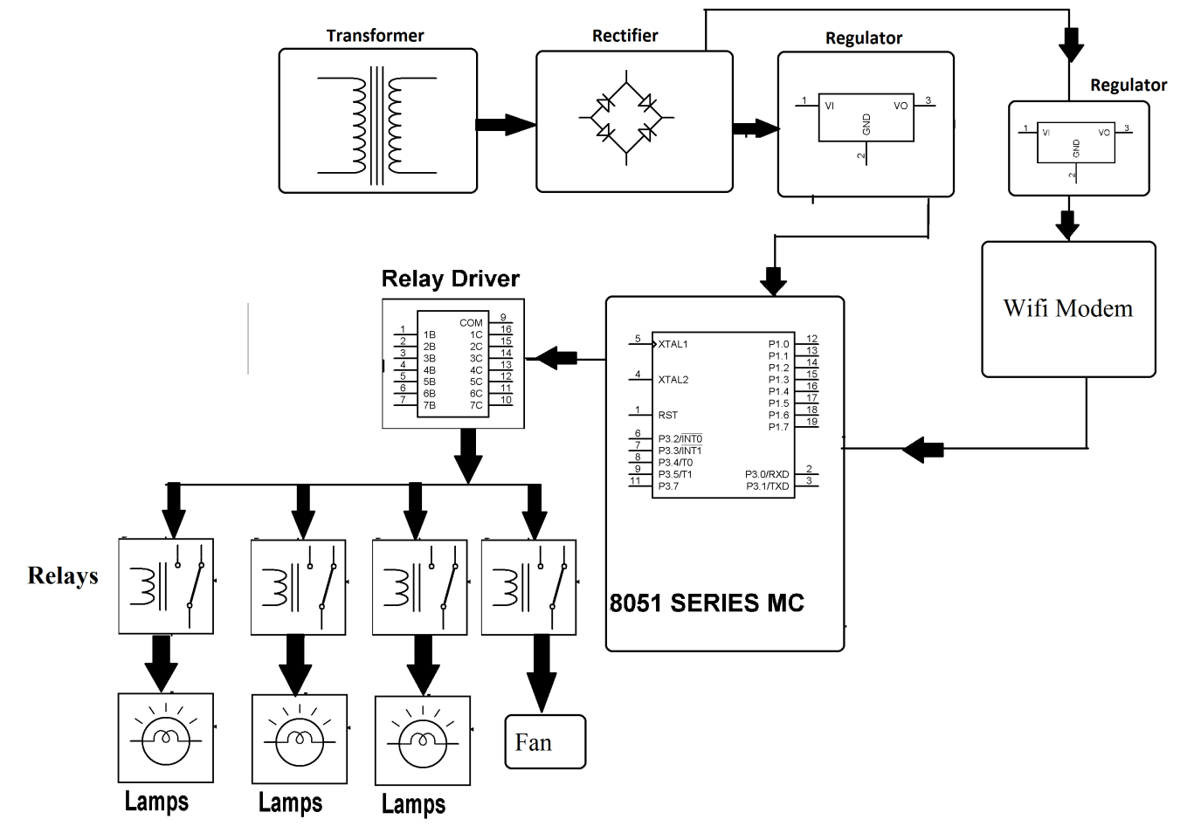

Hardware Specifications
- 8051 series Microcontroller
- Wifi Modem
- Diodes
- Transformer
- Relays
- Voltage Regulator
- Crystal
- Lamps
- LED
- Relay Driver IC

Software Specifications
- Keil µVision IDE
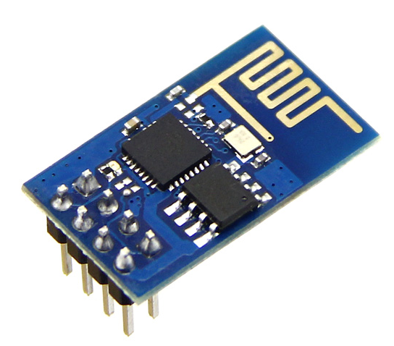
- MC Programming Language: Embedded C
WIFI Modem:
The ESP8266 WiFi Module is a self contained SOC with integrated TCP/IP protocol stack that can give any microcontroller access to your WiFi network. The ESP8266 is capable of either hosting an application or offloading all Wi-Fi networking functions from another application processor. Each ESP8266 module comes pre-programmed with an AT command set firmware. The ESP8266 module is an extremely cost effective board with a huge, and ever growing, community.
This module has a powerful enough on-board processing and storage capability that allows it to be integrated with the sensors and other application specific devices through its GPIOs with minimal development up-front and minimal loading during runtime. Its high degree of on-chip integration allows for minimal external circuitry, including the front-end module, is designed to occupy minimal PCB area. The ESP8266 supports APSD for VoIP applications and Bluetooth co-existance interfaces, it contains a self-calibrated RF allowing it to work under all operating conditions, and requires no external RF parts.
There is an almost limitless fountain of information available for the ESP8266, all of which has been provided by amazing community support. In the Documents section below you will find many resources to aid you in using the ESP8266, even instructions on how to transforming this module into an IoT (Internet of Things) solution!
Note: The ESP8266 Module is not capable of 5-3V logic shifting and will require an external Logic Level Converter. Please do not power it directly from your 5V dev board.

Features:
802.11 b/g/n
Wi-Fi Direct (P2P), soft-AP
Integrated TCP/IP protocol stack
Integrated TR switch, balun, LNA, power amplifier and matching network
Integrated PLLs, regulators, DCXO and power management units
+19.5dBm output power in 802.11b mode
Power down leakage current of <10uA
1MB Flash Memory
Integrated low power 32-bit CPU could be used as application processor
SDIO 1.1 / 2.0, SPI, UART
STBC, 1×1 MIMO, 2×1 MIMO
A-MPDU & A-MSDU aggregation & 0.4ms guard interval
Wake up and transmit packets in < 2ms
Standby power consumption of < 1.0mW (DTIM3)

Reference
- http://ieeexplore.ieee.org/xpl/articleDetails.jsp?arnumber=7322825&queryText=iot%20home%20automation&newsearch=true

- http://ieeexplore.ieee.org/xpl/articleDetails.jsp?arnumber=7342646&queryText=iot%20home%20automation&newsearch=true

